PD LAB

ASSIGNMENT - 6

Name: Raunak Thanawala

Registration Number: 231070051

Branch: Computer Engineering

Batch: 3

**Aim:-**

Create image editor using tkinter and OpenCV in Python

**Theory:-**

- OpenCV stands for Open Source Computer Vision Library.

- It is a powerful library focused on real-time computer vision and image processing.

- It was initially developed by Intel, now maintained by the OpenCV community.

- Applications:

* Image analysis: Basic image processing techniques.
* Object detection: Identifying and recognizing objects in images.
* Motion tracking: Analyzing the movement of objects.

- Main Concepts:

* Image representation: Uses multi-dimensional arrays for images.
* Color spaces: Supports various representations (e.g., RGB, HSV).
* Image filtering: Convolution operations for enhancing or extracting features.

- Main Modules:

* Core module: Consists of basic data structures and functions.
* Imgproc module: Filtering and transformations.
* Objdetect module: Object detection algorithms.
* HighGUI module: Tools for GUIs and image display.

- Algorithms and Techniques:

* Filtering: Gaussian blur, median filtering.
* Edge detection: Canny and Sobel operators.
* Contour detection: Identifying shape boundaries.

- Performance Optimization:

* Multithreading: Utilizes multiple CPU cores.
* Hardware acceleration: Supports CUDA and OpenCL for GPU processing.

-It is compatible with Windows, macOS, Linux, Android, and iOS and is versatile for developers and researchers in computer vision.

**Code and Output:**

CODE:

import cv2

import numpy as np

from tkinter import *

from tkinter import filedialog, messagebox, colorchooser, Menu

from PIL import Image, ImageTk, ImageDraw

class ImageEditor:

def __init__(self, master):

self.master = master

self.master.title("Basic Image Editor")

self.master.geometry("800x600")

self.image = None

self.drawing_canvas = Image.new("RGB", (800, 600), "white")

self.start_x = self.start_y = None

self.drawing_shape = "pencil"

self.brush_color = "black"

self.brush_size = 3

self.is_drawing = False

self.shape_obj = None

self.saved_filename = None

self.canvas = Canvas(master, bg='white')

self.canvas.pack(fill=BOTH, expand=True)

self.setup_menu()

self.setup_buttons()

def setup_menu(self):

menubar = Menu(self.master)

file_menu = Menu(menubar, tearoff=0)

file_menu.add_command(label="New", command=self.new_image)

file_menu.add_command(label="Load", command=self.load_image)

file_menu.add_command(label="Save", command=self.save_image)

menubar.add_cascade(label="File", menu=file_menu)

tools_menu = Menu(menubar, tearoff=0)

tools_menu.add_command(label="Pencil", command=lambda: self.set_shape("pencil"))

tools_menu.add_command(label="Eraser", command=lambda: self.set_shape("eraser"))

shapes_menu = Menu(tools_menu, tearoff=0)

shapes_menu.add_command(label="Line", command=lambda: self.set_shape("line"))

shapes_menu.add_command(label="Rectangle", command=lambda: self.set_shape("rectangle"))

shapes_menu.add_command(label="Oval", command=lambda: self.set_shape("oval"))

tools_menu.add_cascade(label="Shapes", menu=shapes_menu)

menubar.add_cascade(label="Tools", menu=tools_menu)

self.master.config(menu=menubar)

def setup_buttons(self):

button_frame = Frame(self.master)

button_frame.pack(pady=10)

Label(button_frame, text="Brush Size:").pack(side=LEFT, padx=5)

self.brush_size_scale = Scale(button_frame, from_=1, to=20, orient=HORIZONTAL, command=self.set_brush_size)

self.brush_size_scale.set(3)

self.brush_size_scale.pack(side=LEFT, padx=5)

color_button = Button(button_frame, text="Select Color", command=self.choose_color, width=10)

color_button.pack(side=LEFT, padx=5)

crop_button = Button(button_frame, text="Crop", command=self.start_crop, width=10)

crop_button.pack(side=LEFT, padx=5)

def new_image(self):

self.image = None

self.drawing_canvas = Image.new("RGB", (800, 600), "white")

self.canvas.delete("all")

self.saved_filename = None

def load_image(self):

filename = filedialog.askopenfilename()

if filename:

self.image = cv2.imread(filename)

self.display_image(self.image)

self.saved_filename = filename

def display_image(self, img):

img_rgb = cv2.cvtColor(img, cv2.COLOR_BGR2RGB)

img_tk = ImageTk.PhotoImage(Image.fromarray(img_rgb))

self.canvas.create_image(0, 0, anchor=NW, image=img_tk)

self.canvas.image = img_tk

def choose_color(self):

if (color := colorchooser.askcolor()[1]):

self.brush_color = color

def set_brush_size(self, size):

self.brush_size = int(size)

def set_shape(self, shape):

self.drawing_shape = shape

self.canvas.unbind("<B1-Motion>")

self.canvas.unbind("<ButtonPress-1>")

self.canvas.unbind("<ButtonRelease-1>")

if shape in ["pencil", "eraser"]:

self.canvas.bind("<B1-Motion>", self.draw)

self.canvas.bind("<ButtonPress-1>", self.start_drawing)

self.canvas.bind("<ButtonRelease-1>", self.stop_drawing)

else:

self.canvas.bind("<ButtonPress-1>", self.start_shape)

self.canvas.bind("<B1-Motion>", self.draw_temp_shape)

self.canvas.bind("<ButtonRelease-1>", self.finish_shape)

def start_drawing(self, event):

self.is_drawing = True

self.last_x, self.last_y = event.x, event.y

def stop_drawing(self, event):

self.is_drawing = False

def draw(self, event):

if self.is_drawing:

if self.drawing_shape == "pencil":

self.canvas.create_line(self.last_x, self.last_y, event.x, event.y,

fill=self.brush_color, width=self.brush_size, capstyle=ROUND, smooth=True)

self.draw_on_image(self.last_x, self.last_y, event.x, event.y)

elif self.drawing_shape == "eraser":

self.canvas.create_line(self.last_x, self.last_y, event.x, event.y,

fill='white', width=self.brush_size, capstyle=ROUND, smooth=True)

self.draw_on_image(self.last_x, self.last_y, event.x, event.y, erase=True)

self.last_x, self.last_y = event.x, event.y

def start_shape(self, event):

self.start_x, self.start_y = event.x, event.y

self.shape_obj = None

def draw_temp_shape(self, event):

self.canvas.delete("temp")

if self.drawing_shape == "line":

self.shape_obj = self.canvas.create_line(self.start_x, self.start_y, event.x, event.y,

fill=self.brush_color, width=self.brush_size, tags="temp")

elif self.drawing_shape == "rectangle":

self.shape_obj = self.canvas.create_rectangle(self.start_x, self.start_y, event.x, event.y,

outline=self.brush_color, width=self.brush_size, tags="temp")

elif self.drawing_shape == "oval":

self.shape_obj = self.canvas.create_oval(self.start_x, self.start_y, event.x, event.y,

outline=self.brush_color, width=self.brush_size, tags="temp")

def finish_shape(self, event):

self.canvas.delete("temp")

if self.drawing_shape == "line":

self.shape_obj = self.canvas.create_line(self.start_x, self.start_y, event.x, event.y,

fill=self.brush_color, width=self.brush_size)

elif self.drawing_shape == "rectangle":

self.shape_obj = self.canvas.create_rectangle(self.start_x, self.start_y, event.x, event.y,

outline=self.brush_color, width=self.brush_size)

elif self.drawing_shape == "oval":

self.shape_obj = self.canvas.create_oval(self.start_x, self.start_y, event.x, event.y,

outline=self.brush_color, width=self.brush_size)

self.draw_on_image(self.start_x, self.start_y, event.x, event.y)

def draw_on_image(self, x1, y1, x2=None, y2=None, erase=False):

draw = ImageDraw.Draw(self.drawing_canvas)

if x2 is None and y2 is None:

r = self.brush_size // 2

if erase:

draw.ellipse([x1 - r, y1 - r, x1 + r, y1 + r], fill="white")

else:

draw.ellipse([x1 - r, y1 - r, x1 + r, y1 + r], fill=self.brush_color, outline=self.brush_color)

else:

if self.drawing_shape == "line":

if erase:

draw.line([x1, y1, x2, y2], fill="white", width=self.brush_size)

else:

draw.line([x1, y1, x2, y2], fill=self.brush_color, width=self.brush_size)

elif self.drawing_shape == "rectangle":

if erase:

draw.rectangle([x1, y1, x2, y2], fill="white")

else:

draw.rectangle([x1, y1, x2, y2], outline=self.brush_color, width=self.brush_size)

elif self.drawing_shape == "oval":

if erase:

draw.ellipse([x1, y1, x2, y2], fill="white")

else:

draw.ellipse([x1, y1, x2, y2], outline=self.brush_color, width=self.brush_size)

def start_crop(self):

self.canvas.bind("<ButtonPress-1>", self.start_crop_rectangle)

self.canvas.bind("<B1-Motion>", self.draw_crop_rectangle)

self.canvas.bind("<ButtonRelease-1>", self.finish_crop)

def start_crop_rectangle(self, event):

self.start_x, self.start_y = event.x, event.y

self.crop_rectangle = self.canvas.create_rectangle(self.start_x, self.start_y, self.start_x, self.start_y,

outline='red', width=2)

def draw_crop_rectangle(self, event):

self.canvas.coords(self.crop_rectangle, self.start_x, self.start_y, event.x, event.y)

def finish_crop(self, event):

self.canvas.unbind("<ButtonPress-1>")

self.canvas.unbind("<B1-Motion>")

self.canvas.unbind("<ButtonRelease-1>")

end_x, end_y = event.x, event.y

crop_box = (min(self.start_x, end_x), min(self.start_y, end_y),

max(self.start_x, end_x), max(self.start_y, end_y))

self.crop_image(crop_box)

self.canvas.delete(self.crop_rectangle)

def crop_image(self, crop_box):

if self.image is not None:

img_pil = Image.fromarray(self.image)

*# Crop the image using the bounding box*

cropped_img = img_pil.crop(crop_box)

*# Display the cropped image back in the canvas*

self.drawing_canvas = Image.new("RGB", (800, 600), "white") *# Reset drawing canvas*

self.display_image(np.array(cropped_img)) *# Show cropped image*

self.image = np.array(cropped_img) *# Update the main image to the cropped one*

self.saved_filename = None

def save_image(self):

if self.image is not None:

combined_image = Image.new("RGB", (800, 600))

combined_image.paste(Image.fromarray(self.image), (0, 0))

*# Create a new image with an alpha channel to combine the drawings*

drawing_with_alpha = self.drawing_canvas.convert("RGBA")

*# Create a mask for the drawing*

mask = Image.new("L", drawing_with_alpha.size, 255) *# White mask*

combined_image.paste(drawing_with_alpha, (0, 0), mask)

file_path = filedialog.asksaveasfilename(defaultextension=".png",

filetypes=[("PNG Files", "*.png"), ("JPEG Files", "*.jpg")])

if file_path:

combined_image.save(file_path)

if __name__ == "__main__":

root = Tk()

app = ImageEditor(root)

root.mainloop()

OUTPUT:

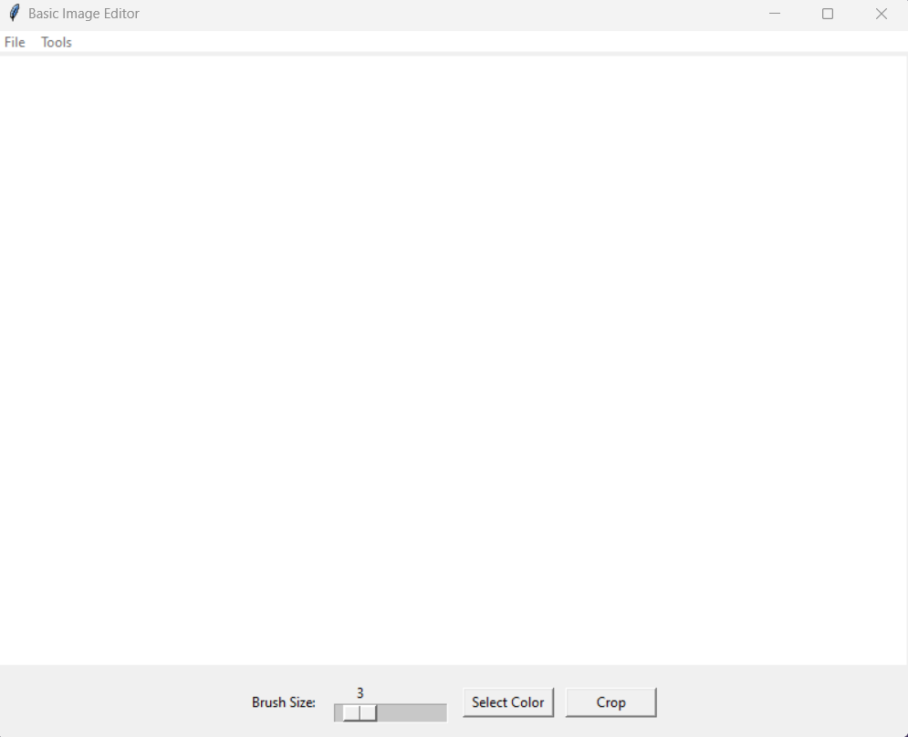

What you see when you run the program

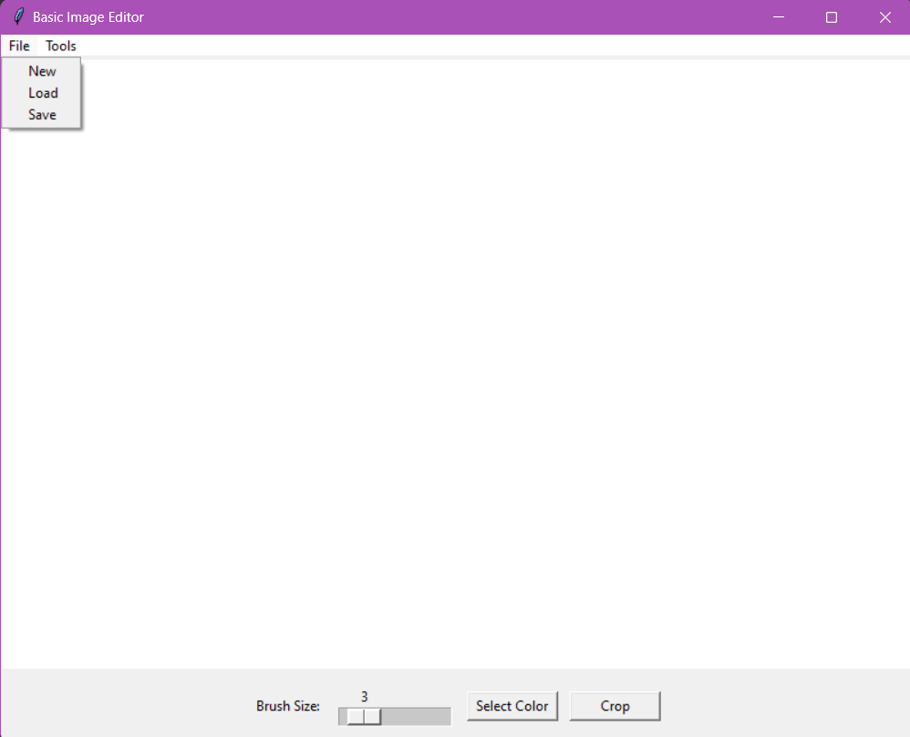

When you click File

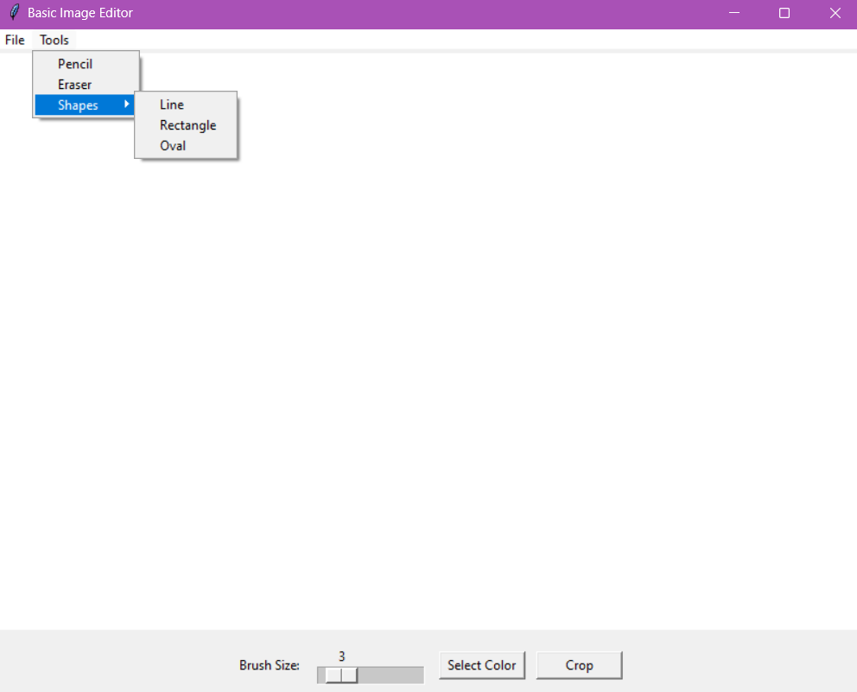

When you click Tools and hover over Shapes

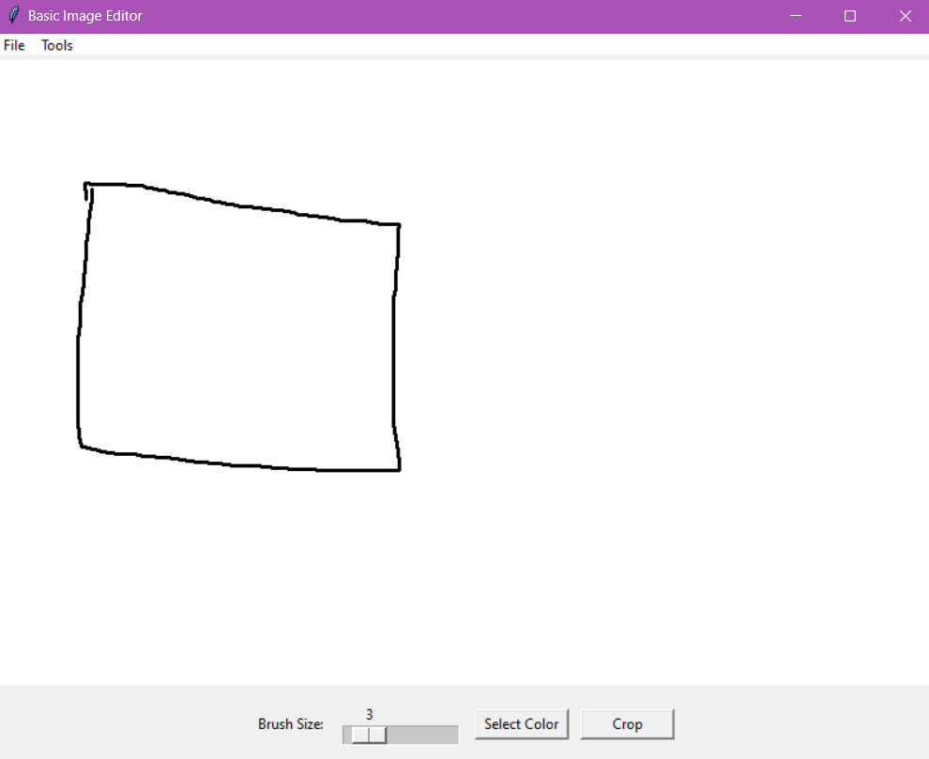  
When you draw with pencil

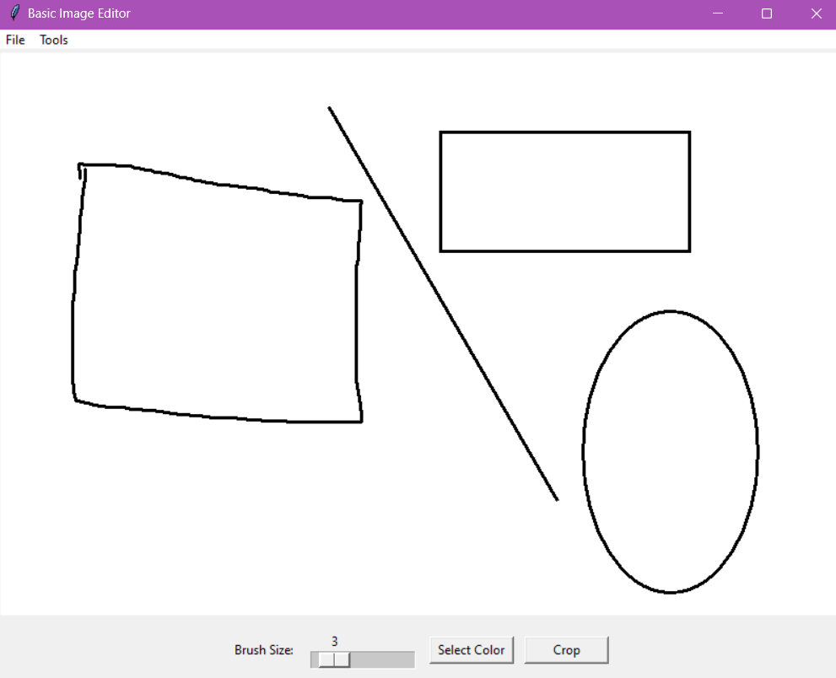  
When you draw a line, a rectangle and an oval

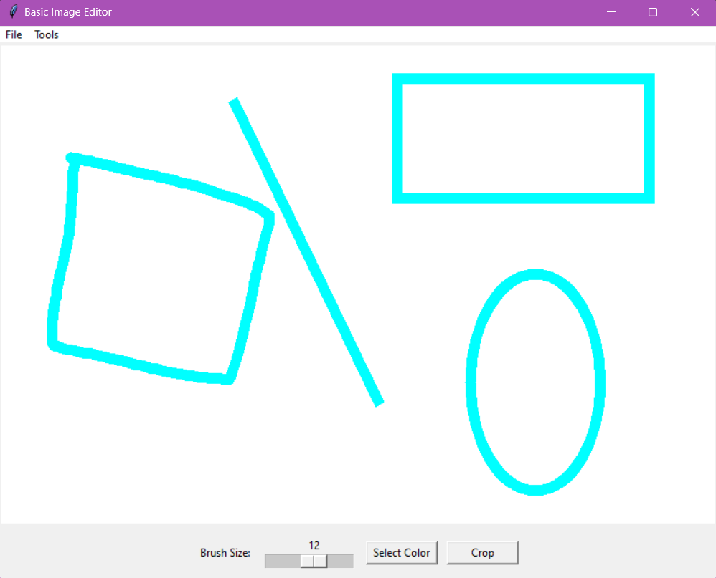  
When you increase brush size and change color and redraw with all the brushes and the shapes

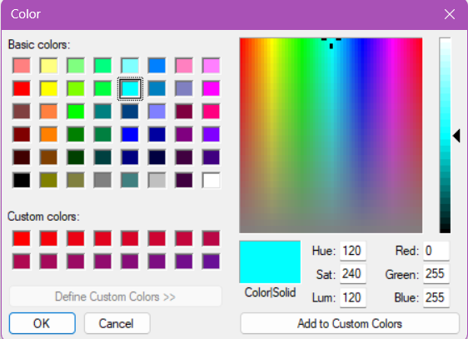  
The color menu

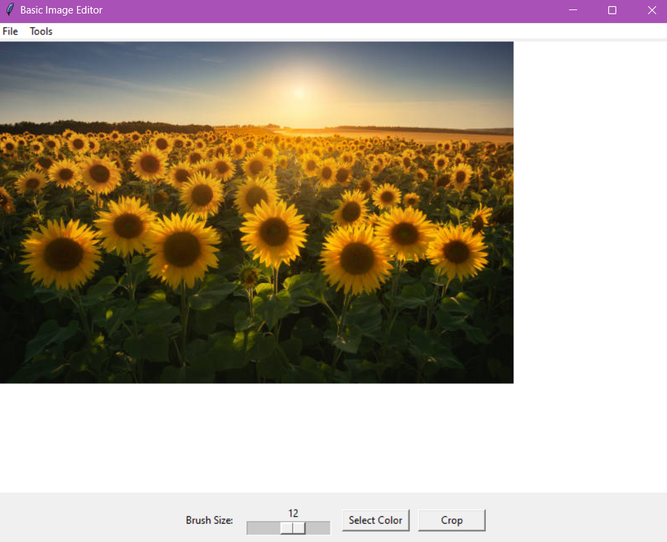  
When you load an image

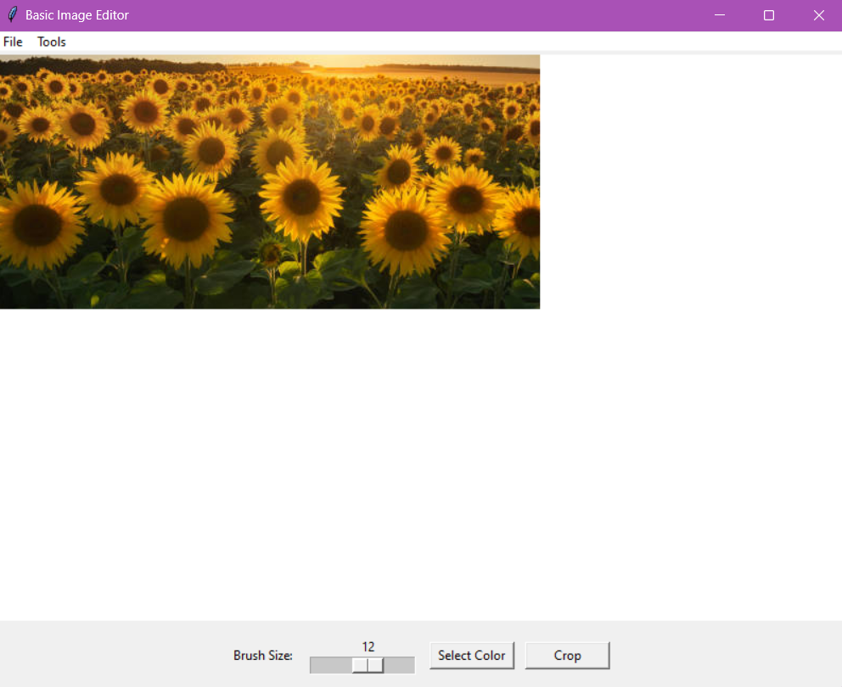  
After cropping the image

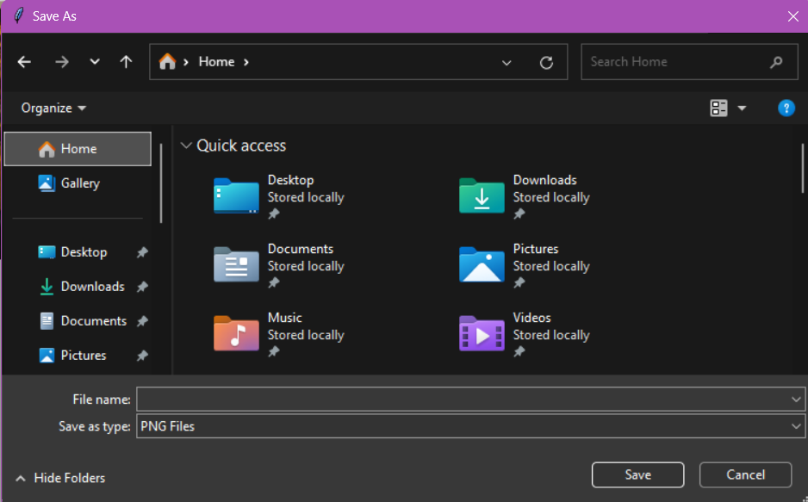

When you click Save

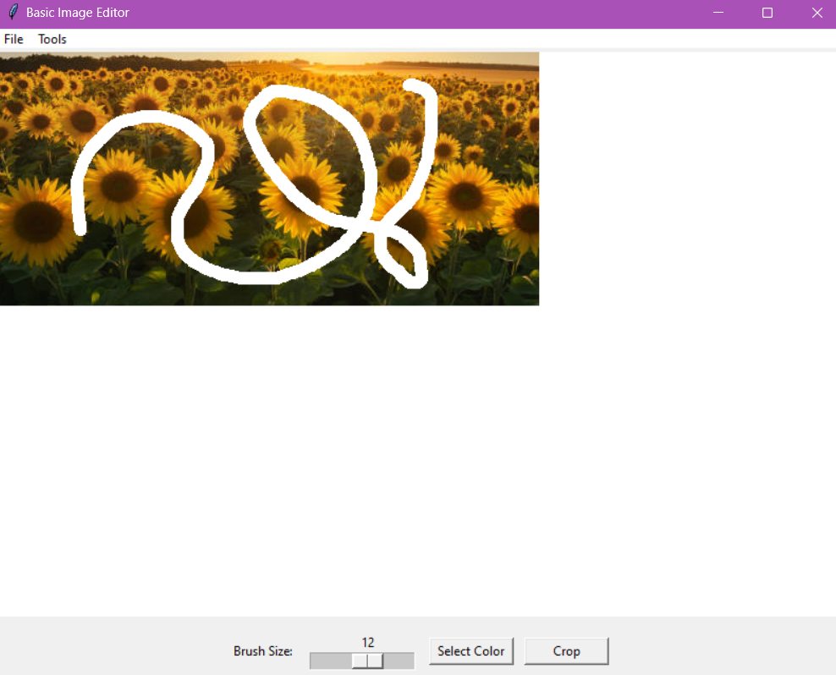  
When you use the Eraser

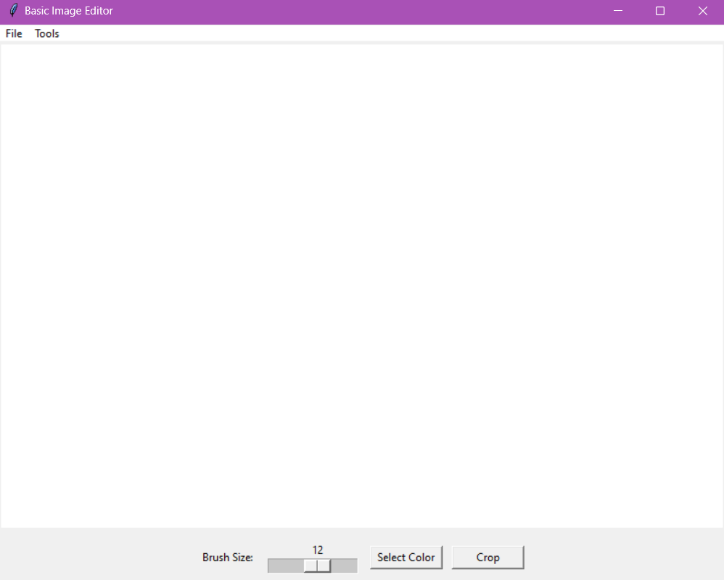  
When you click New

**Conclusion:**

Thus we have written a program to make an image editor using opencv in python with the help of tkinter.

The Image Editor has the basic functions of Making a new blank canvas, Loading in any image from your pc, Saving the new image, Drawing with the help of a pencil or shapes such as Lines, Rectangles and Ovals, We also have an Eraser Feature.

We can also increase the size of the brush which changes the thickness of the pencil, and the multiple different shapes.

We can also crop loaded images how we see fit.